**Histogram Matching**

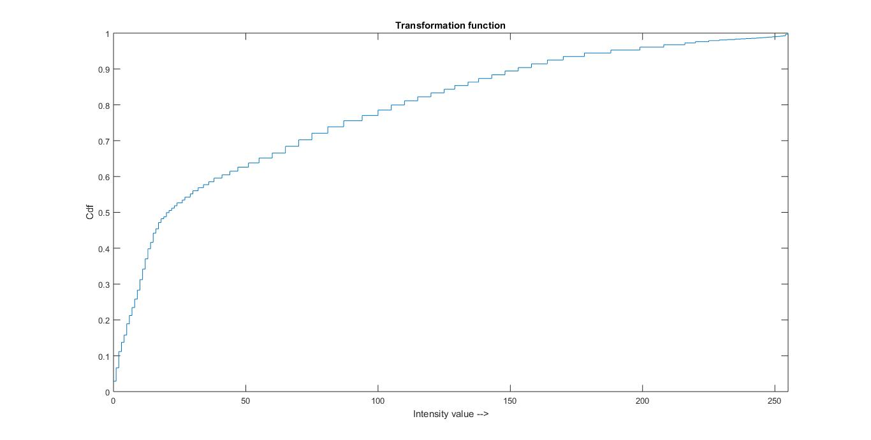

* Transformation function for histogram matching

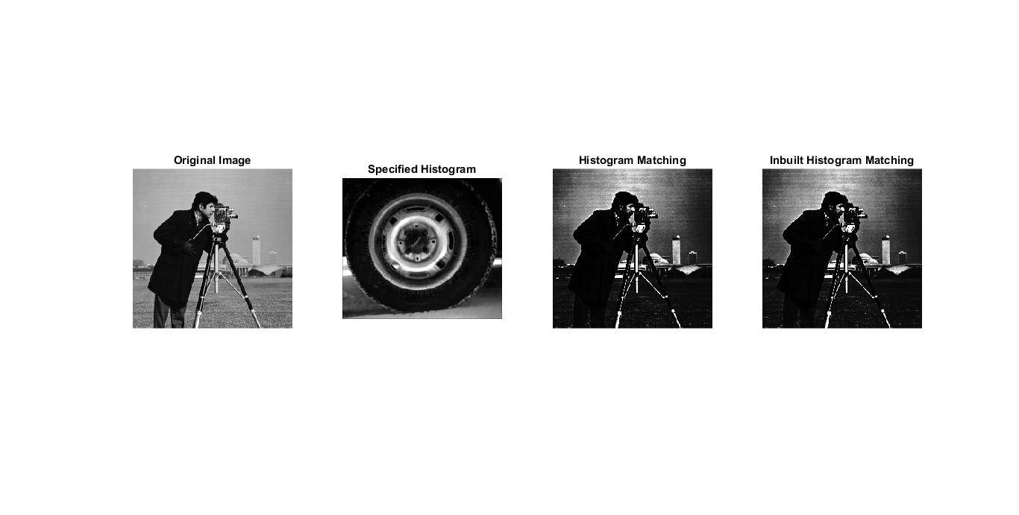

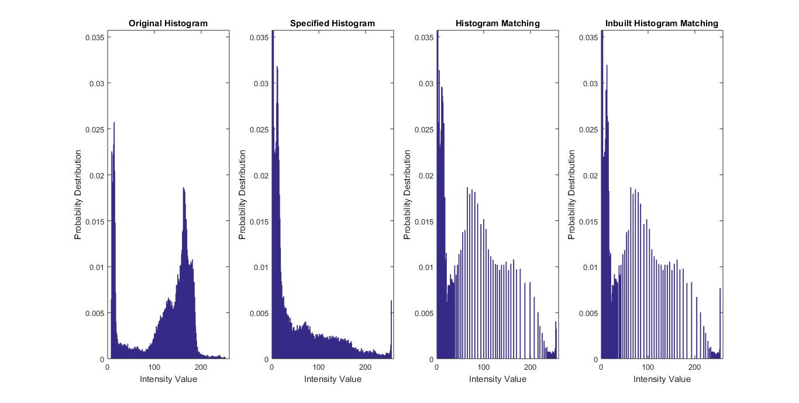

* The original histogram is dense within 100-200 pixel values and has less pixel intensity values from 200-255 and between 0 to 10.
* The specified histogram is dense between 0 to 10 i.e. has more intensity values closer to black. This is the histogram that we wish to have for the original image.
* We observe that the histogram shape changes after matching and is more closer to specified intensity value in region of 0 to 10. While it is approximately uniformly spread in other regions. Due to many pixels being closer to black, the transformed image is also more black than previous values.
* Also, the histogram after matching is very similar to the inbuilt histogram matching
* We observe the RMSE of 1.56 from the inbuilt histogram matching.